**Understanding State:**

State is a graphical representation for specifying business processes in a workflow. It's designed to be easily understood by both technical and non-technical users.

**Key Elements in this State Diagram:**

* **Start Events (Circles):** Represented by a single circle, these mark the beginning of each process. In this diagram, all four processes have a "intialize" start event.
* **Tasks (Rectangles with Rounded Corners):** Represent activities performed within the process. Each task is labeled with a description of the action.
* **Gateways (Diamonds):** Used to control the flow of the process. In this diagram, there are no explicit gateways, implying a straight sequential flow.
* **Sequence Flows (Arrows):** Connect the elements of the process, showing the order in which they occur.
* **End Events (Circles with Thicker Borders):** Represent the completion of a process. In this diagram, all four processes have an "End" event.
* **Text Annotations (Rectangles with Folded Corners):** Provide additional information or context to the process.

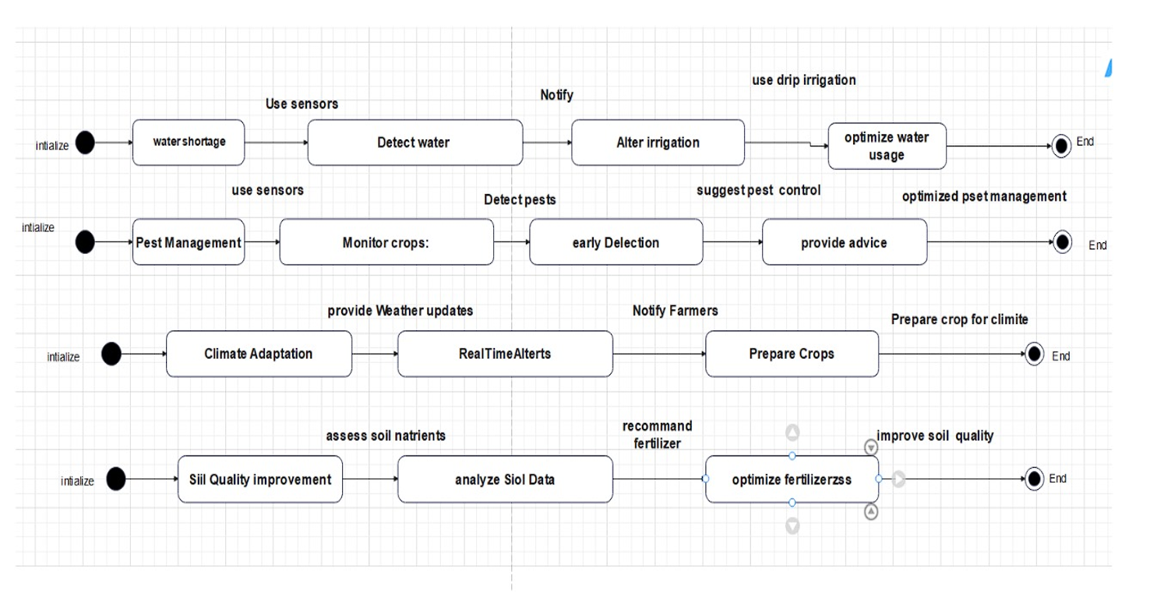

**Analyzing the Four Processes:**

1. **Water Management:**
   * **Start Event:** "intialize"
   * **Task:** "water shortage" (This likely represents a condition or trigger, not a task in the traditional sense)
   * **Task:** "Use sensors"
   * **Task:** "Detect water"
   * **Task:** "Notify"
   * **Task:** "Alter irrigation"
   * **Text Annotation:** "use drip irrigation"
   * **Task:** "optimize water usage"
   * **End Event:** "End"
   * **Interpretation:** This process represents how the system manages water resources. It starts with a water shortage trigger, uses sensors to detect water levels, notifies the user, alters irrigation (potentially using drip irrigation), and optimizes water usage.
2. **Pest Management:**
   * **Start Event:** "intialize"
   * **Task:** "Pest Management" (Again, likely a condition or trigger)
   * **Task:** "Monitor crops:"
   * **Task:** "use sensors"
   * **Task:** "Detect pests"
   * **Task:** "early Delection" (Likely meant to be "early Detection")
   * **Task:** "suggest pest control"
   * **Task:** "provide advice"
   * **Text Annotation:** "optimized pset management" (Likely meant to be "optimized pest management")
   * **End Event:** "End"
   * **Interpretation:** This process describes how the system manages pests. It monitors crops, uses sensors to detect pests, provides early detection, suggests pest control measures, and provides advice for optimized pest management.
3. **Climate Adaptation:**
   * **Start Event:** "intialize"
   * **Task:** "Climate Adaptation" (Again, likely a condition or trigger)
   * **Task:** "provide Weather updates"
   * **Task:** "Real Time Alterts" (Likely meant to be "Real Time Alerts")
   * **Task:** "Notify Farmers"
   * **Task:** "Prepare Crops"
   * **Text Annotation:** "Prepare crop for climite" (Likely meant to be "Prepare crops for climate")
   * **End Event:** "End"
   * **Interpretation:** This process outlines how the system helps farmers adapt to climate conditions. It provides weather updates, real-time alerts, notifies farmers, and helps them prepare their crops for climate changes.
4. **Soil Quality Improvement:**
   * **Start Event:** "intialize"
   * **Task:** "Siil Quality Improvement" (Likely meant to be "Soil Quality Improvement")
   * **Task:** "assess soil natrients" (Likely meant to be "assess soil nutrients")
   * **Task:** "analyze Siol Data" (Likely meant to be "analyze Soil Data")
   * **Task:** "recommand fertilizer" (Likely meant to be "recommend fertilizer")
   * **Task:** "optimize fertilizerzss" (Likely meant to be "optimize fertilizer use")
   * **Text Annotation:** "improve soil quality"
   * **End Event:** "End"
   * **Interpretation:** This process describes how the system helps improve soil quality. It assesses soil nutrients, analyzes soil data, recommends fertilizer, and optimizes fertilizer use to improve soil quality.

**Overall Interpretation:**

This BPMN diagram provides a high-level overview of four key processes in a smart agriculture system: water management, pest management, climate adaptation, and soil quality improvement. Each process is represented as a sequential flow of tasks, starting with an initialization event and ending with a completion event. The diagram effectively illustrates the steps involved in each process and the overall functionality of the system.

**Key Observations:**

* The processes are simplified, focusing on the main steps.
* The use of text annotations provides additional context.
* The diagram highlights the system's ability to monitor, analyze, and respond to various agricultural factors.
* There are several spelling errors in the diagram, which should be corrected for clarity.